Images and Captions
Inline chart image:
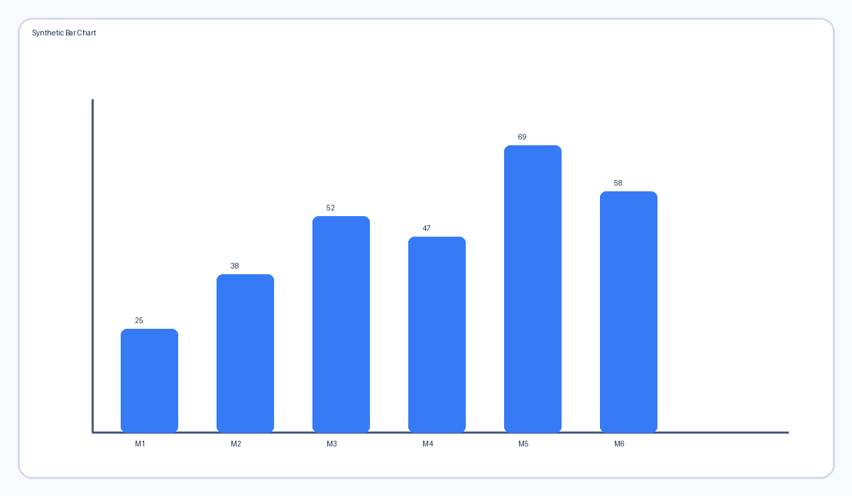
Figure 1: Synthetic bar chart caption
Repeated image use on another section:

Transparent logo-like image:

Visually similar but binary-different pair:
